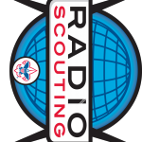World of Amateur Radio
sender
Has satisfactorily demonstrated how to send his/her
name using Morse Code
Sent
Has satisfactorily demonstrated how to send his/her
name using Morse Code
Sent
FREE ADMISSION
Annual RAWNY Youth Night Tuesday, November 10, 2015 7:00PM to 9:00PM

The Church of the Nativity 1530 Colvin Blvd, Kenmore, NY (One block north of Sheridan)

World of Amateur Radio
Annual RAWNY Youth Night Tuesday, November 10, 2015 7:00PM to 9:00PM
FREE ADMISSION

The Church of the Nativity 1530 Colvin Blvd, Kenmore, NY (One block north of Sheridan)

JOTA JOTA JOTA JOTA JOTA JOTA JOTA

Jamboree-On-The-Air
JOTA
J O I N T H E F U N
JOTA

International Scouting Event October 17, 2015
JOTA
at the Onondaga District Camporee

Buffalo Niagara Heritage Village
3755 Tonawanda Creek Road, Amherst

JOTA JOTA JOTA JOTA JOTA JOTA JOTA

Jamboree-On-The-Air
JOTA
J O I N T H E F U N

International Scouting Event October 17, 2015
JOTA
at the Onondaga District Camporee

Buffalo Niagara Heritage Village
JOTA
3755 Tonawanda Creek Road, Amherst

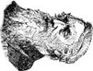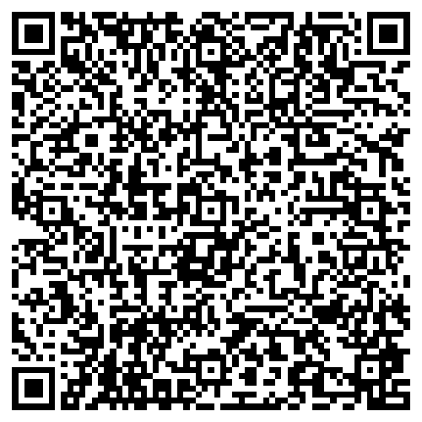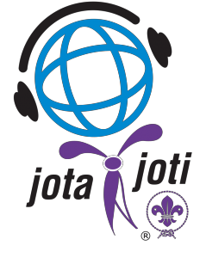JOTA JOTA JOTA JOTA JOTA JOTA JOTA
Be it known that
Name
of
morse
code
Official
signature
Date
Official Signature
Date
Samuel Morse
JOTA
Be it known that
Name
of
morse
code
sender
Official
signature
Date
Official Signature
Date
Samuel Morse
JOTA
JOTA
JOTA
JOTA
JOTA
JOTA JOTA JOTA JOTA JOTA JOTA JOTA

